WFL Machines Manufacture Key Components for Aerospace

WFL Multifunction Turning and Milling Centers are employed across various industries, with aerospace being a significant market. ArianeGroup, at the forefront of space transportation, stands as a prime example of utilizing MILLTURN machines. The production of key components necessitates the use of reliable and precise machinery.

The ArianeGroup site in Vernon, France, designs, develops, manufactures, and tests liquid hydrogen propulsion systems. Much of its activity revolves around propulsion for launch vehicles. The site encompasses three test benches for cryotechnic thrusters and component testing benches. In total, six WFL machines are present on the site: four M60 MILLTURN and two M35 MILLTURN, all utilized for machining key components.

MILLTURN Technology at the Heart of Key Component Production

"Machines from WFL are particularly crucial for us as we use them to manufacture high-value parts," states Dominique Delor, Head of Industrial Maintenance. The first M60 MILLTURN was acquired 20 years ago. Since then, three M60s and two M35s have been added to the production hall. Key components or "critical parts" produced on WFL machines are primarily rotating engine parts.

"We primarily require precision and good rigidity in our machines because we machine hard materials that will undergo significant stress during use. Furthermore, process standardization is part of ArianeGroup's business strategy." In production, this entails working with the same machines and the same numerical control. For Dominique Delor, this is undeniable: "It saves us time and allows all our operators to work on these machines."

"Our satisfaction has increased as we gained experience with these machines. We have realized that they are good, sturdy, and reliable machines. Therefore, if we were to need a new machine, we would undoubtedly opt for a MILLTURN. Our colleagues in Ottobrunn, Germany, are also convinced by the MILLTURN. After visiting our production site in Vernon and the subsequent purchase of an M80, they were able to significantly reduce their production time," adds Delor.

Understanding Customer Needs and Building Trust

The Vernon site has been working with WFL machines for 20 years. Dominique Delor asserts, "For 20 years, we have maintained excellent relationships with WFL. Whether your interlocutor is from sales or customer service, competence and trust are present at 100%. WFL understands the customer's needs. For us, in a new project, it is always important to have assurance of a functioning production. And that's the case with WFL. Their service doesn't stop at simply selling a machine. Implementation is also impeccable. By purchasing a WFL machine, we know everything will go smoothly."

"Another reason we are very satisfied with WFL machines is the efficiency of their after-sales service. Our M60 machines are used in three shifts. We produce complex parts and always have to ensure quality and adherence to delivery deadlines. WFL's after-sales service is extremely competent and fast. When we need spare parts, we receive them promptly, and everything works perfectly”, explains the Head of Industrial Maintenance, Dominique Delor.

Maintaining Performance Constantly

ArianeGroup produces a considerable number of parts each year, maintaining a constant and significant activity on the machines. Any rejects are therefore excluded; each piece must be perfect and meet very precise specifications. Quality is an absolute priority in our workshops," Mr. Delor emphasizes.

"With WFL, we can guarantee this quality. Indeed, one of the great advantages of these machines is adherence to tolerances. Currently, we manually control tolerances, but in the future, we would like to implement automated control. This should contribute, on one hand, to reducing production time, and on the other hand, to cost savings. We want to utilize machine data and information to plan production in advance through predictive maintenance."

Growing Demand Requires Perfect Mastery of Production

Due to the constantly increasing demand, the technical requirements imposed on launch vehicles are also rising. Mr. Delor sees the improvement and digitization of production as a decisive project for the years to come. "I am convinced that with WFL, we will also be able to upgrade our production in terms of monitoring and predictive maintenance."

en Contact:
WFL Millturn Technologies GmbH & Co. KG
Wahringerstraße 36, A-4030 Linz
Tel. +43 732-6913-0
www.wfl.at

Photos:

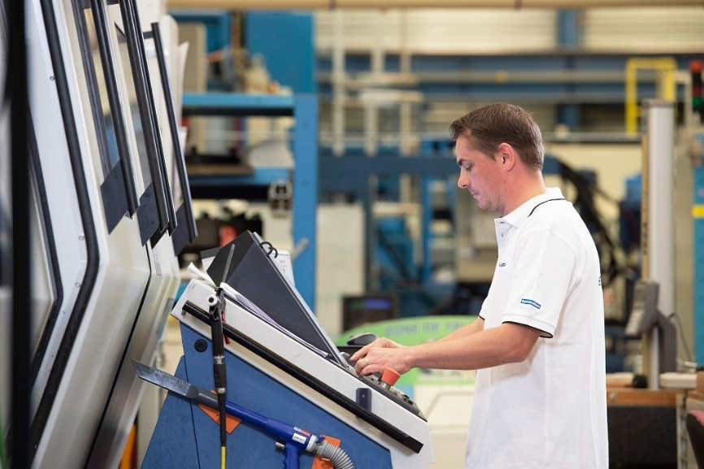
Copyright: ArianeGroup Holding / Master Image Programmes / Thomas Leaud
01: ArianeGroup - Vernon has been using WFL Millturn machines for 20 years. The high precision and rigidity of the machines, as well as customer service, are particularly appreciated.

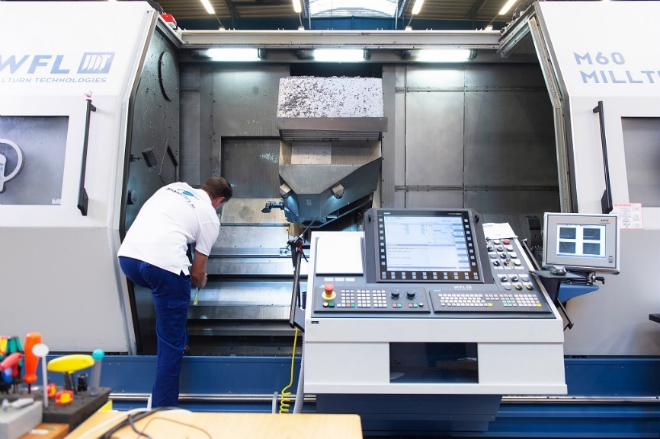
Copyright: ArianeGroup Holding / Master Image Programmes / Thomas Leaud
02: Millturn machines in Vernon produce a large number of components for complex engines.

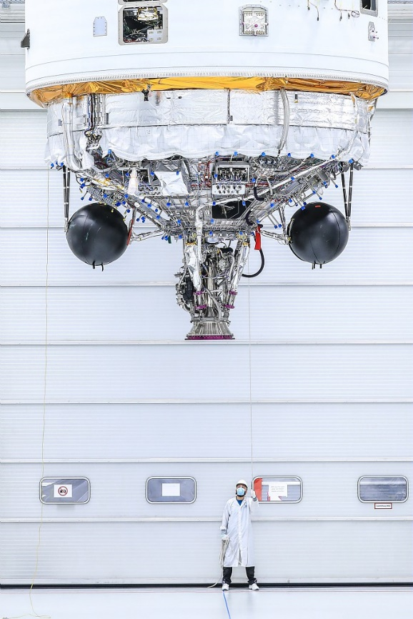
03: The Vinci engine represents the latest generation of engines. It was developed by ArianeGroup in collaboration with its European partners as part of an ESA program.

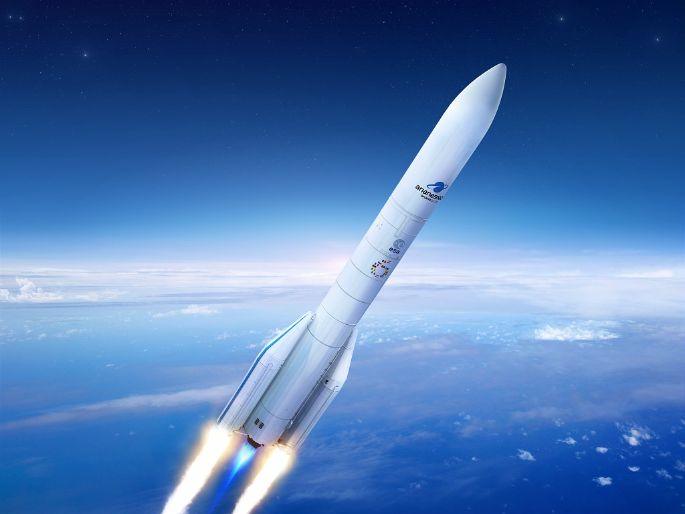
04: During production, there must be no scrap. Every part must be precise. WFL machines help guarantee quality, because one of their major assets is their ability to respect tolerances.

